INHERTANCE:

public class Inheritance{

    private int a=0;

    protected int b=0;

    public int c=0;

    int d=0;

    final int e=0;

    Inheritance(){

        System.out.println("parent object created");

    }

    Inheritance(int a, int b, int c, int d){

        this.a = a;

        this.b = b;

        this.c = c;

        this.d = d;

        System.out.println("parent object created");

    }

    public int sum(int a,int b){

        System.out.println("parent sum");

        return a + b;

    }

}

public class InheritMain extends Inheritance{

    String str;

    InheritMain(){

        System.out.println("child object created");

    }

    InheritMain(int a, int b, int c, int d, String str){

        super(a,b,c,d);

        this.str = str;

        System.out.println("child object created");

    }

    public int sum(int a, int b){

        System.out.println("child sum");

        return a + b;

    }

    public static void main(String []args){

        InheritMain s1 = new InheritMain(1,2,3,4,"inheritance");

        System.out.println(s1.sum(2,2));

        Inheritance s2 = new InheritMain();

        System.out.println(s2.sum(5,5));

        Inheritance s3 = new Inheritance(10,20,30,40);

        System.out.println(s3.sum(10,10));

    }

}

OUTPUT:

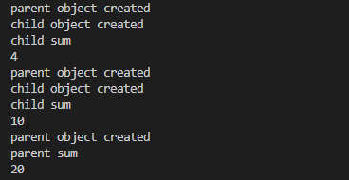

Parent construct will be called first in every case (mentioned or not).

If the child object is created with parent reference, the child method will be called (unlike static case). (eg: s2)